**SPRINT - 4**

|  |  |
| --- | --- |
| **Date** | 18 NOVEMBER 2022 |
| **Team ID** | |  | | --- | | PNT2022TMID06109 | |
| **Project Name** | |  | | --- | | IOT based safety gadget for child safety monitoring and notification | |

**Login page:**

**<!DOCTYPE html>**

**<html>**

**<head>**

**<meta name="viewport" content="width=device-width, initial-scale=1">**

**<style>**

**body {font-family: Arial, Helvetica, sans-serif;}**

**form {border: 3px solid #f1f1f1;}**

**input[type=text], input[type=password] {**

**width: 100%;**

**padding: 12px 20px;**

**margin: 8px 0;**

**display: inline-block;**

**border: 1px solid #ccc;**

**box-sizing: border-box;**

**}**

**button {**

**background-color: #04AA6D;**

**color: white;**

**padding: 14px 20px;**

**margin: 8px 0;**

**border: none;**

**cursor: pointer;**

**width: 100%;**

**}**

**button:hover {**

**opacity: 0.8;**

**}**

**.cancelbtn {**

**width: auto;**

**padding: 10px 18px;**

**background-color: #f44336;**

**}**

**.imgcontainer {**

**text-align: center;**

**margin: 24px 0 12px 0;**

**}**

**img.avatar {**

**width: 40%;**

**border-radius: 50%;**

**}**

**.container {**

**padding: 16px;**

**}**

**span.psw {**

**float: right;**

**padding-top: 16px;**

**}**

**@media screen and (max-width: 300px) {**

**span.psw {**

**display: block;**

**float: none;**

**}**

**.cancelbtn {**

**width: 100%;**

**}**

**}**

**</style>**

**</head>**

**<body>**

**<h2>Login Form</h2>**

**<form action="/action_page.php" method="post">**

**<div class="imgcontainer">**

**</div>**

**<div class="container">**

**<label for="uname"><b>Username</b></label>**

**<input type="text" placeholder="Enter Username" name="uname" required>**

**<label for="psw"><b>Password</b></label>**

**<input type="password" placeholder="Enter Password" name="psw" required>**

**<button type="submit">Login</button>**

**<label>**

**<input type="checkbox" checked="checked" name="remember"> Remember me**

**</label>**

**</div>**

**<div class="container" style="background-color:#f1f1f1">**

**<button type="button" class="cancelbtn">Cancel</button>**

**<span class="psw">Forgot <a href="#">password?</a></span>**

**</div>**

**</form>**

**</body>**

**</html>**

**Output:**

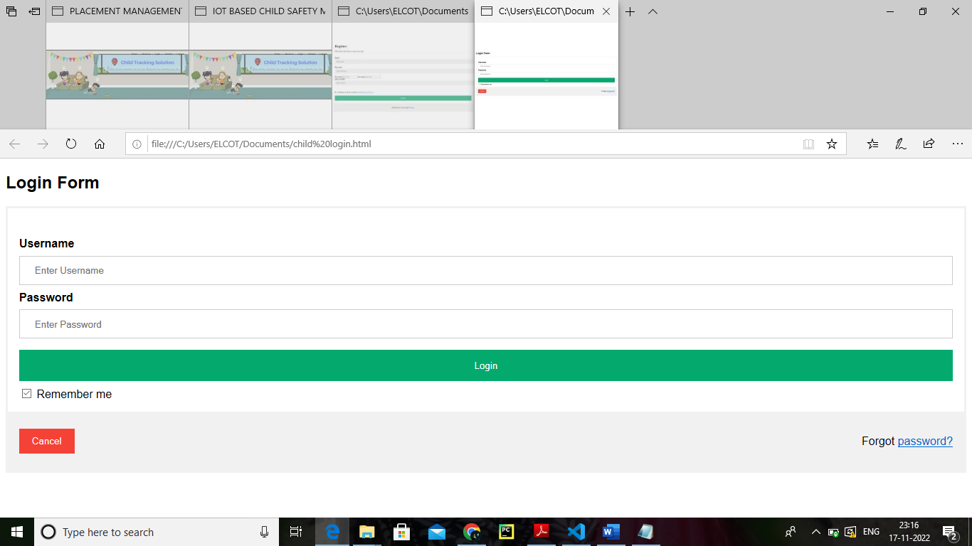

**Step1.html**

**<!DOCTYPE html>**

**<html>**

**<body>**

**<style>**

**h1 {**

**color: darkred;**

**text-align: center;**

**}**

**p {**

**font-family: montserrat;**

**font-size: 20px;**

**}**

**pre{**

**font-family: Timesnewroman;**

**font-size: 30px;**

**}**

**.container{**

**height: 80vh;**

**width: 50%;**

**padding: auto;**

**text-align: center;**

**margin-left: 300px;**

**}**

**.button**

**{**

**align-items: center;**

**font-size: 15px;**

**padding: 20px;**

**}**

**body**

**{**

**background-color: lightcyan;**

**}**

**</style>**

**<h1>**

**IOT Based Safety Gadget for Child Safety Monitoring and Notification**

**</h1>**

**<div class="container">**

**<p style="font-size: 20px;text-align: justify;padding-top: 100px;padding-left: 55px;">**

**Child tracker helps the parents in continuously monitoring the child's location. They can simply leave their children in school or parks and create a geofence around the particular location. By continuously checking the child's location notifications will be generated if the child crosses the geofence. Notifications will be sent according to the child's location to their parents or caretakers. The entire location data will be stored in the database.**

**</p>**

**<br>**

**<a href="step2.html"><button type="submit" class="button">Child Safety Monitoring and Notification</button></a>**

**</div>**

**</body>**

**</html>**

**OUTPUT:**

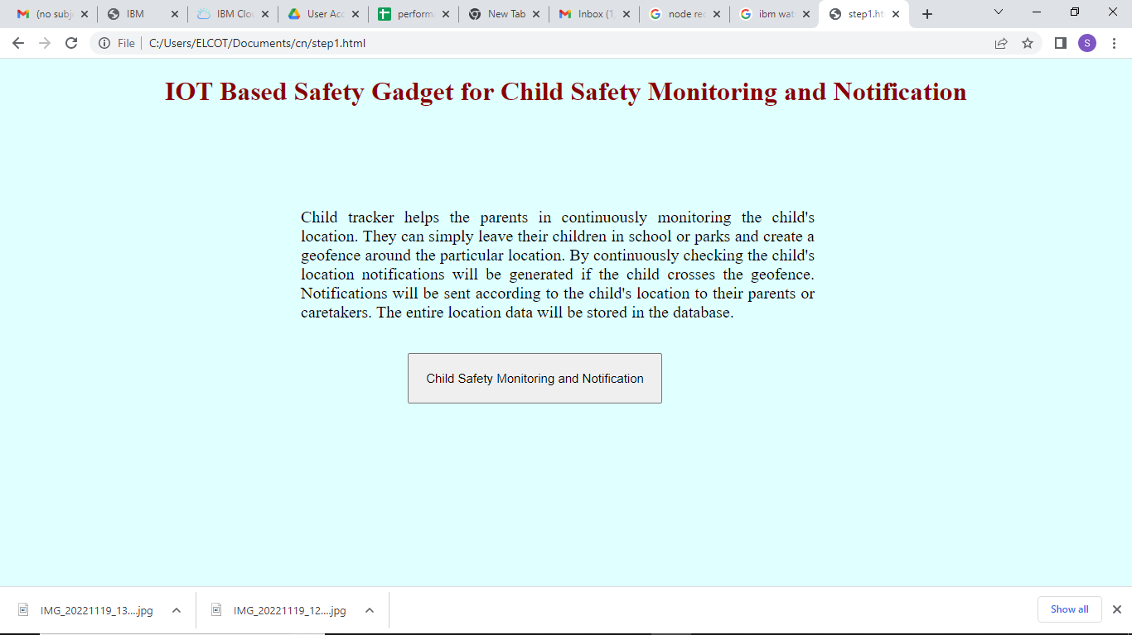

**Step2.html**

<!DOCTYPE html>

<html>

<body>

<style>

h1 {

color: black;

text-align: center;

}

p {

font-family: TimesNewRoman;

font-size: 20px;

}

.container{

height: 100vh;

width: 80%;

padding: auto;

text-align: center;

padding-left: 150px;

}

</style>

<h1>IOT Based Safety Gadget for Child Safety Monitoring and Notification</h1>

<div class="container">

<div>

<a href="step3.html"><img src="C:\Users\ELCOT\Documents\cn\spirit 4\7.jpg" height="200vh"width="20%"></a>

</div>

<div>

<a href="step4.html"><img src="C:\Users\ELCOT\Documents\cn\spirit 4\2.png" height="200vh"width="20%" ></a>

<a href="step1.html"><img src="C:\Users\ELCOT\Documents\cn\spirit 4\1.jpg" height="200vh"width="20%"></a>

<a href="step6.html"><img src="C:\Users\ELCOT\Documents\cn\spirit 4\3.png" height="200vh"width="20%"></a>

</div>

<div>

<a href="step5.html"><img src="C:\Users\ELCOT\Documents\cn\spirit 4\5.png" height="200vh"width="20%"></a>

</div>

</div>

</body>

</html>

**OUTPUT :**

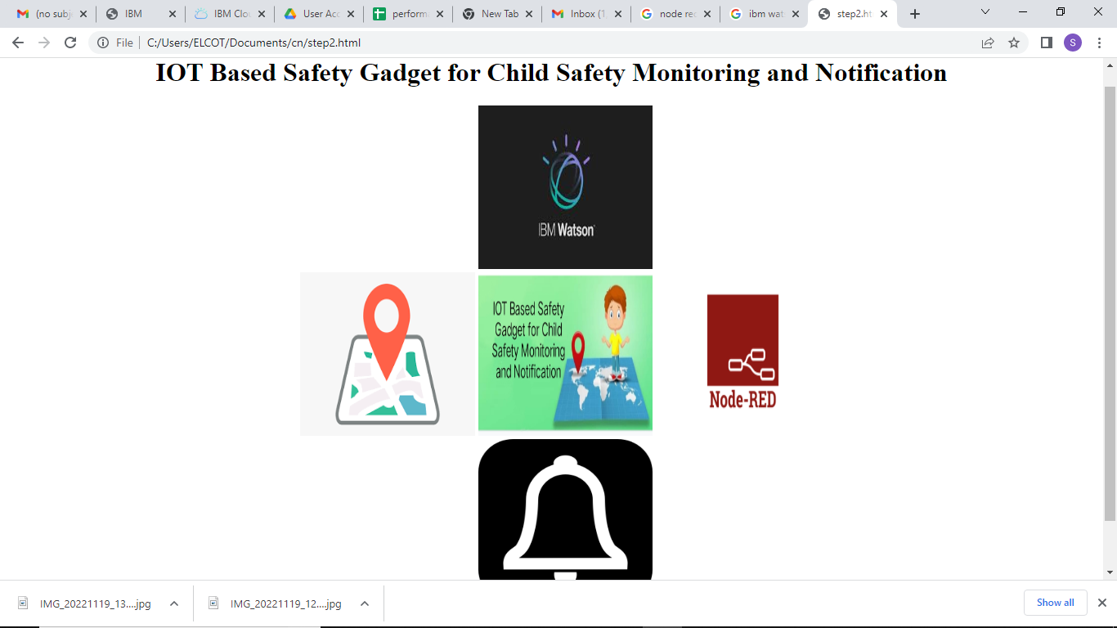

**Step3.html**

<!DOCTYPE html>

<html>

<body>

<style>

h1{

color: darkred;

text-align: center;

}

.container{

height: 80vh;

width: 50%;

padding: auto;

text-align: center;

margin-left: 300px;

}

p {

font-family: TimesNewRoman;

font-size: 20px;

}

.button

{

align-items: center;

margin-bottom: 100px;

}

</style>

<h1>

IBM WATSON

</h1>

<div class="container">

<p>Distance making and track to find the location</p>

<a href="step3.html"><img src="C:\Users\ELCOT\Documents\cn\spirit 4\Ibm Watson.png"height="500vh"width="100%"></a>

<a href="step2.html"><button type="submit" class="button">BACK</button></a>

</div>

</body>

</html>

**OUTPUT:**

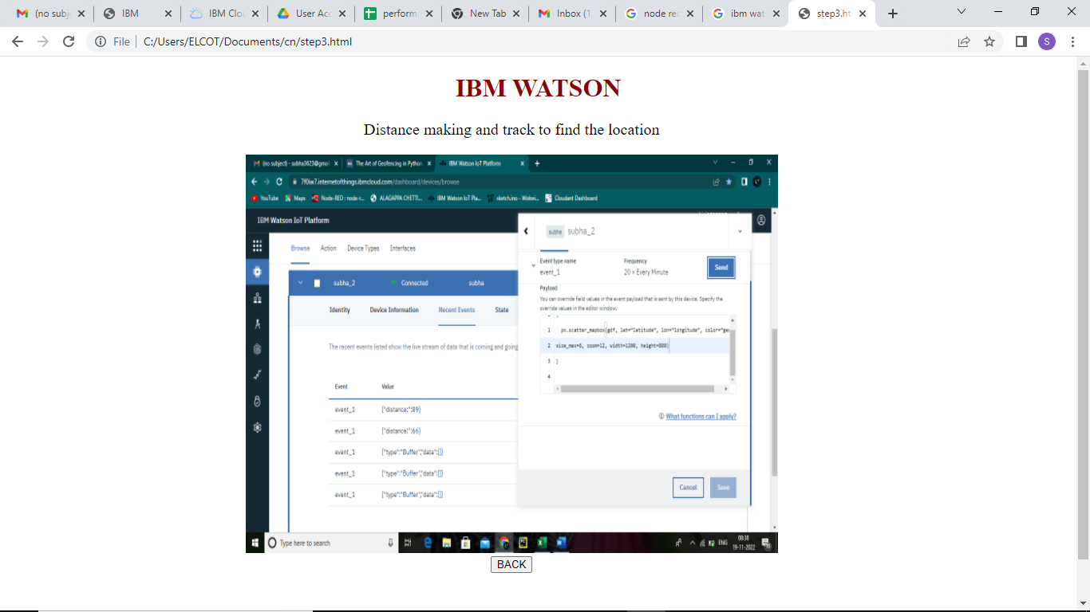

**Step4.html**

<!DOCTYPE html>

<html>

<body>

<style>

h1 {

color: darkreds;

text-align: center;

}

p {

font-family: TimesNewRoman;

font-size: 20px;

}

.container{

height: 80vh;

width: 50%;

padding: auto;

text-align: center;

margin-left: 300px;

}

img

{

height: 700px ;

width: 450px;

}

#center

{

text-align: center;

}

</style>

<h1>

Gps Tracker

</h1>

<div class="container">

<p>Find the location</p>

<div id ="center">

<a href="step2.html"><img src="C:\Users\ELCOT\Documents\cn\spirit 4\Gps1.png" height="200vh"width="20%" ></a>

<a href="step2.html"><img src="C:\Users\ELCOT\Documents\cn\spirit 4\Gps2.jpg" height="200vh"width="20%" ></a>

<a href="step2.html"><img src="C:\Users\ELCOT\Documents\cn\spirit 4\Gps3.jpg" height="200vh"width="20%" ></a>

</div>

<a href="step2.html"><button type="submit" class="button">BACK</button></a>

</div>

</body>

</html>

**OUTPUT :**

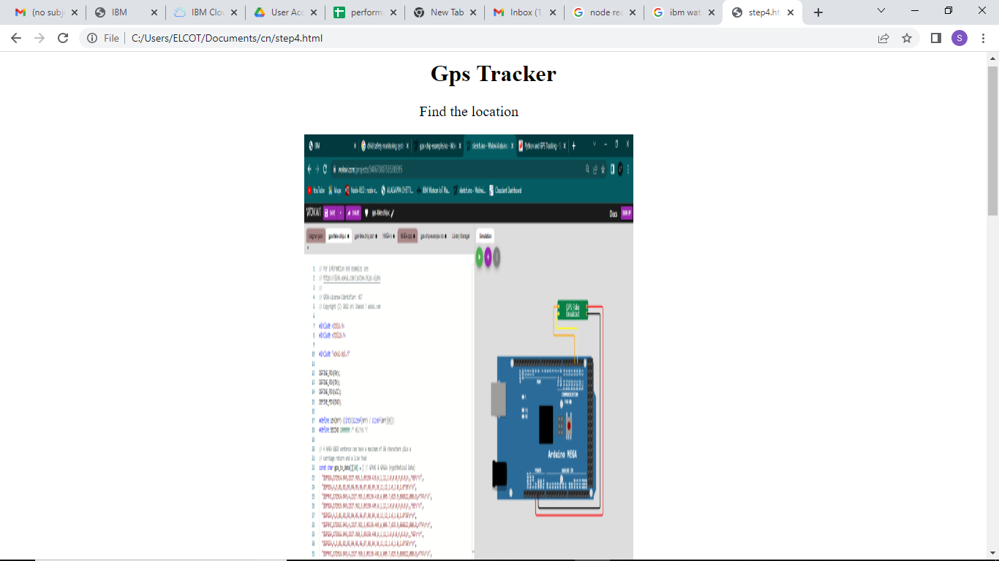

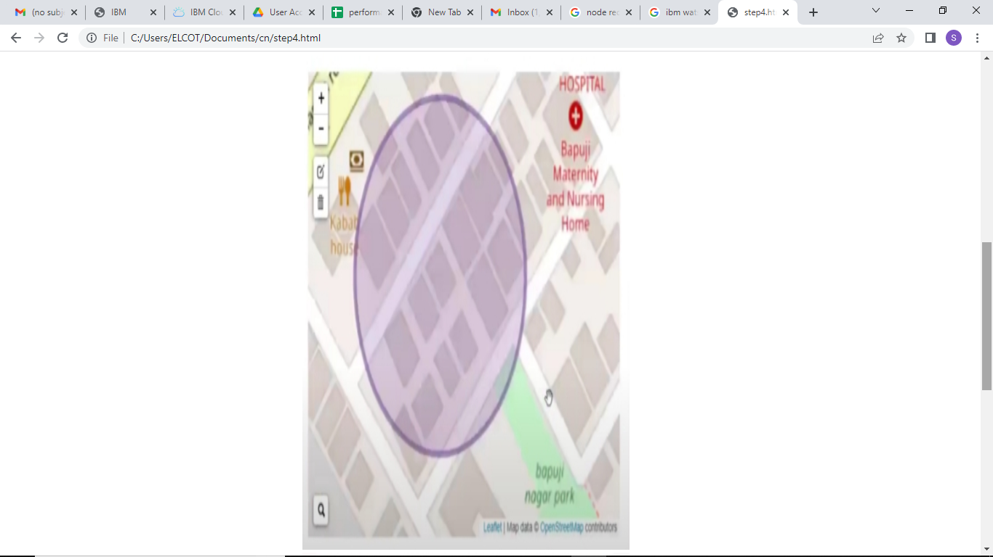

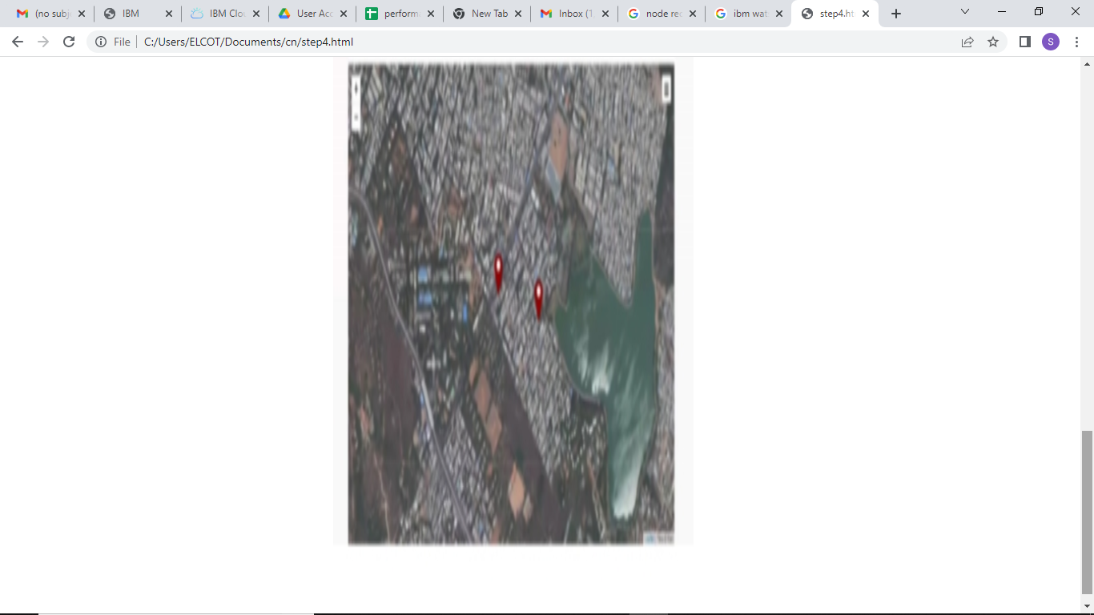

**Step5.html**

**<!DOCTYPE html>**

**<html>**

**<body>**

**<style>**

**h1 {**

**color: darkred;**

**text-align: center;**

**}**

**p {**

**font-family: TimesNewRoman;**

**font-size: 20px;**

**}**

**pre{**

**font-family: TimesNewRoman;**

**font-size: 20px;**

**}**

**.container{**

**height: 80vh;**

**width: 50%;**

**padding: auto;**

**text-align: center;**

**margin-left: 300px;**

**}**

**.button**

**{**

**align-items: center;**

**font-size: 15px;**

**}**

**</style>**

**<h1>**

**Child Safety Monitoring and Notification**

**</h1>**

**<div class="container">**

**<a href="step6.html"><img src="C:\Users\ELCOT\Documents\cn\spirit 4\node red.png" height="500vh"width="100%"></a>**

**<br><br><a href="step2.html"><button type="submit" class="button">BACK</button></a>**

**</div>**

**</body>**

**</html>**

**OUTPUT :**

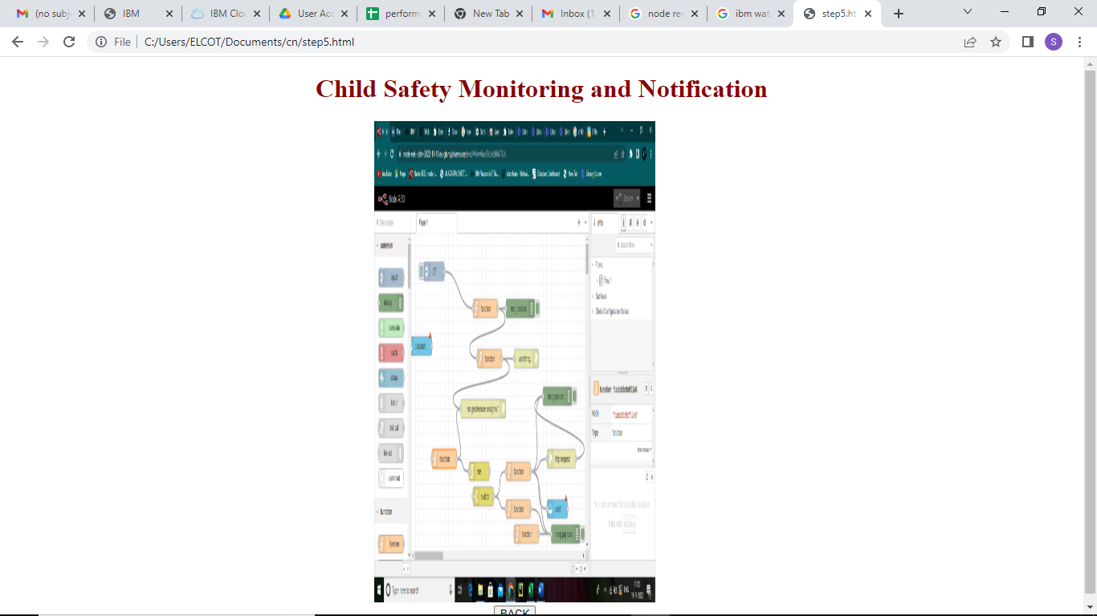

**Step6.html**

**<!DOCTYPE html>**

**<html>**

**<body>**

**<style>**

**h1{**

**color: darkred;**

**text-align: center;**

**}**

**p {**

**font-family: TimesNewRoman;**

**font-size: 20px;**

**}**

**.container{**

**height: 80vh;**

**width: 50%;**

**padding: auto;**

**text-align: center;**

**margin-left: 300px;**

**}**

**img**

**{**

**height: 600px ;**

**width: 350px;**

**}**

**#center**

**{**

**text-align: center;**

**}**

**</style>**

**<h1>**

**NOTIFICATION**

**</h1>**

**<div class="container">**

**<p>To track the location and send the notification to parents</p>**

**<div id ="center">**

**<a href="step2.html"><img src="C:\Users\ELCOT\Documents\cn\spirit 4\notification.jpg" height="700vh"width="50%"></a>**

**</div>**

**<a href="step2.html"><button type="submit" class="button">BACK</button></a></div>**

**</body>**

**</html>**

**OUTPUT :**

